### Author

Manukumar B

21f1005305

[21f1005305@student.onlinedegree.iitm.ac.in](mailto:21f1005305@student.onlinedegree.iitm.ac.in)

I’m a working professional at SAP Labs India – Bangalore. I hold BE (B Tech) degree in CSE from Siddaganga Institute of technology Tumkur, Karnataka.

### Description

This project is meant to design/develop an App which can track different activities an individual may be doing for health and fitness. The app helps to aggregate the activity data and help understand the progress. Possibly, adjust the future activities better to achieve the goal.

### Technologies used

* Flask
  + For web application framework
* SQLite & flask_sqlalchemy
  + For persistency of data
  + For interacting with SQLite db as an ORM
* Bootstrap & JINJA2
  + For UI & aesthetic
* flask_login, flask_security
  + For user management, session, and authentication
* Matplotlib, NumPy
  + For plotting graphical charts
  + For statistical computations
* Csv, base64
  + For data exporting
  + For converting image to base64image string
* JavaScript
  + For client-side validation and dynamicity

### DB Schema Design

* Users can sign up to the app using their email id which is unique.
* A user can have more than one tracker Hence, the relation between the USER and TRACKER is one to many
* Further there can be more than one log entry for each tracker Hence, the relation between TRACKER and ACTIVITY is also one to many.
* Each table has primary key as id which is configured to be auto generated.

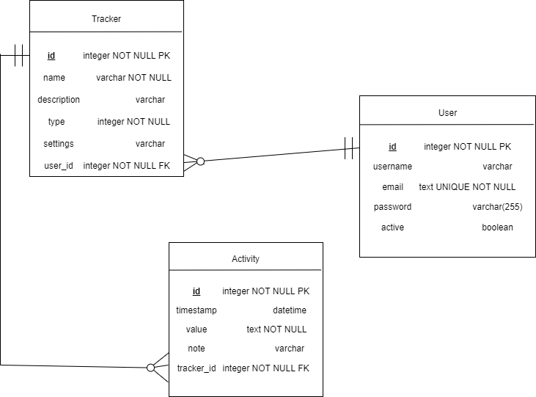

### Architecture and Features

For most part of the application the code is organised as per MVC architecture

**Models**

USER, TRACKER and ACTIVITY

**VIEWS**

DASHBOARD, Create/Update tracker, Create/Update activity

**Controller**

Tracker controller and activity controller

* Application is subscription based, meaning user sign up to the application using their email id along with a password of user choice.
* Home page or Dashboard upon login lists the existing trackers created by user along with option to create/edit/remove trackers.
* Each tracker has option to log data against it from options provided in the table.
* Create/Update forms get auto adjusted based on user need for ex: tracker type, log type.
* There are 4 types of trackers user can create based on the data type it collects
  + Numeric (A positive value)
  + Multiple choice (option1, option2 …)
  + Time Duration (HH:mm:ss)
  + Boolean (yes/no)
* Tracker overview lets user to view the logs per tracker and with some stats and figures.
* User also has export to CSV as an option to download his data for further use.

### Video

<<Link to your online video of not more than 3 minutes length>>